User Manual

FMS^{NG} Application

Shell Energy Marketing and Trading India Private Limited
Project Sponsoring Business

INVENTORY

14 MARCH 2024
Date

Table of Contents
1. Inventory Module Overview 3
1.1. User Interface / Screen Designs 3
2. Menu Network / Screen Navigation 4
2.1. Sub Module – Inventory 4
3. Report Design and Layout 7
4. Auditing 8

Inventory Module Overview
FMS^{NG} Application is an efficient ETRM System for Domestic Gas Trading, customized to meet business requirement of Shell Energy Marketing and Trading India Private Limited (SEMTIPL).
FMS^{NG} Inventory Module will allow to manage all critical Inventory elements of the trading system as listed below:
- Energy Bank

User Interface / Screen Designs

FMS^{NG} offers Responsive UI to enable usability via any smart phone, tab and laptop of any screen size. The Menus of Inventory module are as below:

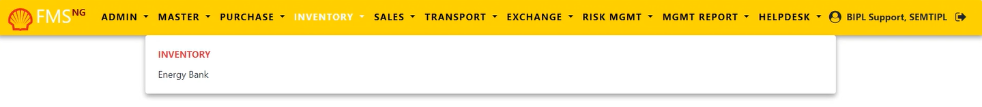

The responsive mode view over iPhone simulation:
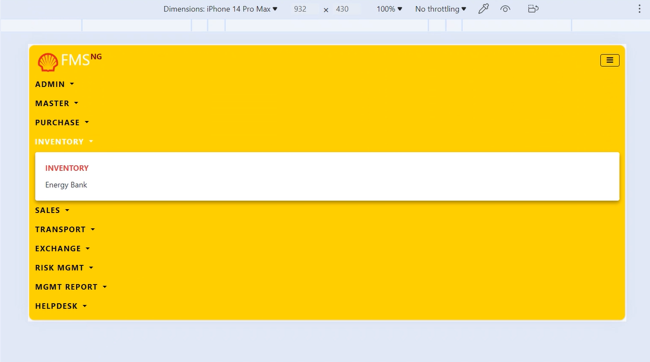

Menu Network / Screen Navigation
Menus in any Module are kept under different Groups for better categorization. The Groups under Inventory Module is Inventory.

Sub Module – Inventory

‘Inventory’ Group provides form to manage various Energy bank/Inventory related operations within the application.

Inventory Energy Bank

This form incorporates 'Energy Bank' with 'Unloaded MMBTU' and ‘Expected MMBTU’ functionalities within the FMS^{NG} application.

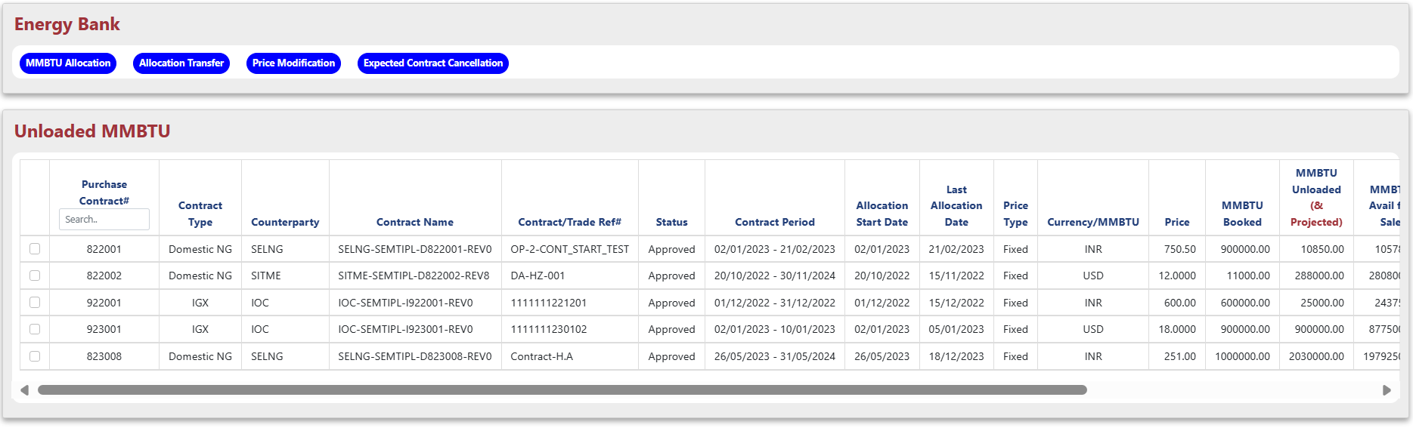
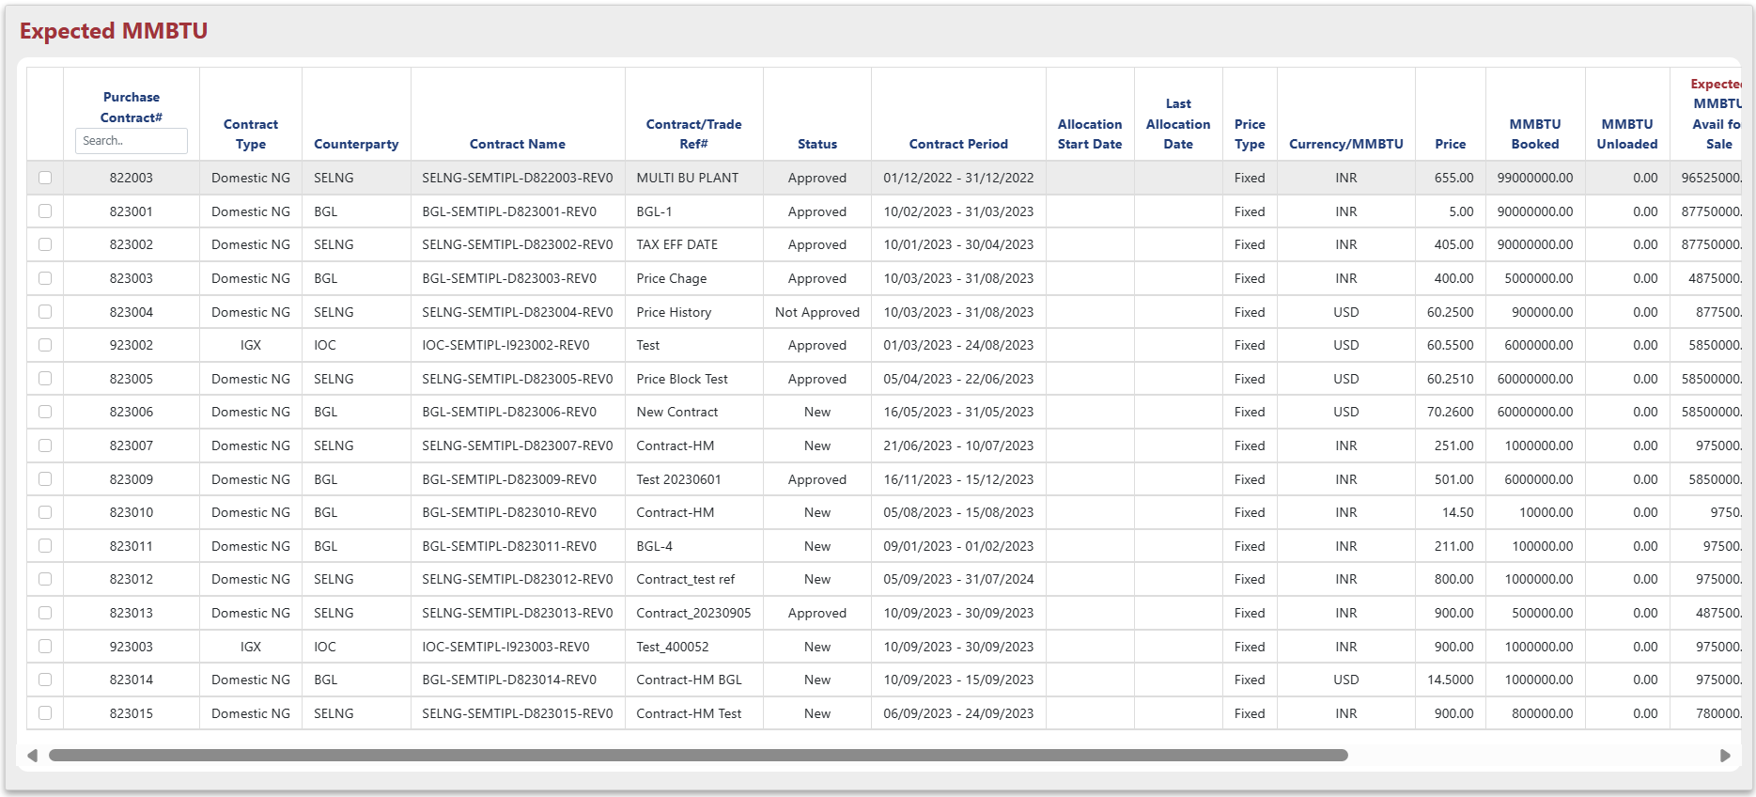

- The "Energy Bank" report provides a consolidated view of both unloaded and expected mmbtu volumes.
- Report also allows you assign (allocate) and adjust prices (modify price).
- Assign MMBTU to Buy contracts: Select the contracts using the checkboxes next to their numbers, then click the "MMBTU Allocation" button at the top.
- Clicking the "MMBTU Allocation" button opens a new window for assigning MMBTU.
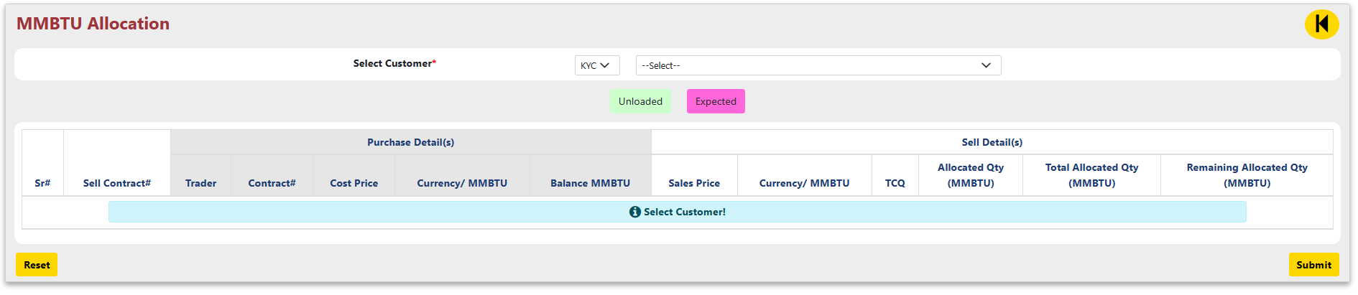

- Choose a customer and the corresponding KYC/IGX option from the dropdown menus.

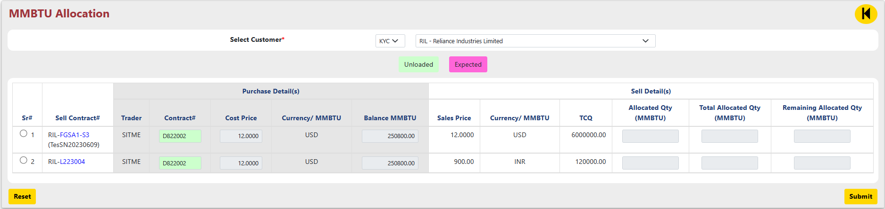

  - To allocate quantity, select a contract using the radio button next to its number and then enter the quantity to allocate.
  - Please make sure “Total Allocated Qty should equal Contract TCQ for the selected Contract”.
  - After entering the allocation quantity, click "Submit" to review a detailed confirmation message about the allocation. If the details are correct, click "Ok" to proceed.

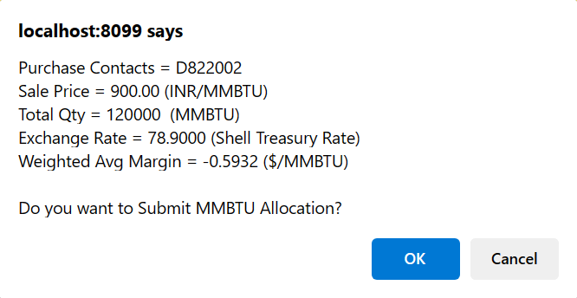

  - Click on  button to go back to main page.

- Price modification to contracts: Select the contracts using the checkboxes next to their numbers, then click the "Price Modification" button at the top.
- Clicking the "Price Modification" button opens a new window for modifying the Price.

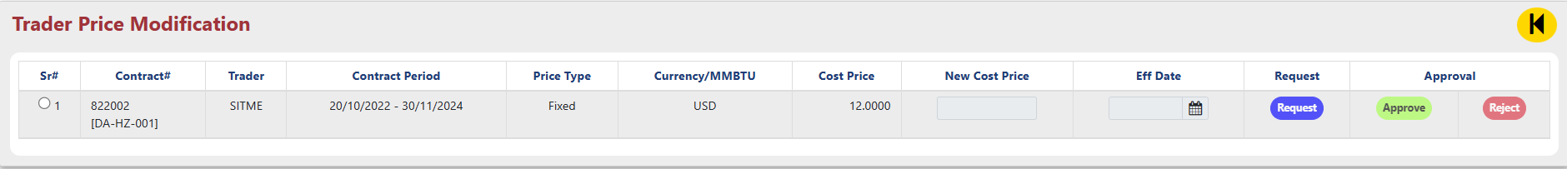

  - To modify price, select a contract using the radio button next to its number and then enter the new cost price and the effective date.

  - Click on  button to request the new price then ‘Ok’ in confirmation message.

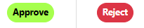

- ‘Approve/Reject’ button allows to approve or reject the price modification request.
- Clicking as desired action button shows up the detailed message, click on ‘Ok’ to proceed the action.

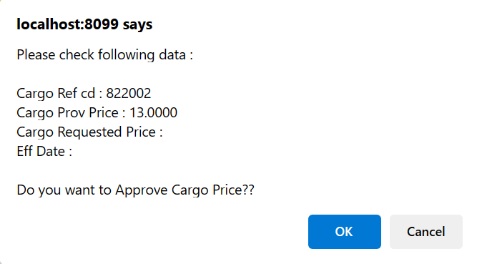

- Click on  button to go back to main page.

Report Design and Layout

For your reference, detailed information about these reports is provided above:

- Energy Bank

Auditing
The "Audit Trail" within the "Admin" module comprehensively tracks and stores all user actions performed across the various sub-menus of the "Inventory" module, providing a detailed record of changes made to the system's master data.

